***CRF 115066***

**Query**

select a.registration_date,

a.complaint_id as Docket_No,

decode(a.customer_type, '1', 'Customer', '2', 'Non customer') Customer_type,

decode(a.customer_call,

'1',

'enquerry',

'2',

'compliant',

'3',

'suggestion') Customer_call,

decode(a.customer_serch,

'0',

'Mobile no',

'1',

'Customer_id',

'2',

'Pledge_no') Customer_search,

a.source,

a.enterd_by as Assigned_User,

b.call_type as Ticket_Type,

a.priority,

c.dispositionname,

d.subdispositionname,

a.natureofcomplaint,

a.customer_name,

a.contactno,

a.details_of_complaint,

a.modified_date,

a.registration_date as close_time,

a.language,

a.abit_mafil,

a.branch_id,

bt.BRANCH_NAME,

bt.state_name,

bt.reg_name,

bt.area_name,

a.product,

a.appointmentdate,

a.existng_cust_no,

a.pin_code,

bb.branch_addr || ',' || bb.branch_add1 || ',' || bb.branch_add2 || ',' ||

bb.branch_add3 || ',' || bb.branch_add4 || ',' || bb.branch_add5 branch_Address,

decode(a.status, '0', 'New_data', '1', 'Modification_data') status_type,

a.EXISTING_CUST_NAME,

a.EXIS_CUST_MOB,

a.cust_call_frm,

a.non_cust_call_frm,

a.MODIFIED_BY,

a.MODIFIED_DATE,

s.ticket_st,

i.action_type,

a.ticket_remarks,

a.pledge_weight,

a.pledge_amount,

a.EMPLOYMENT_PROFILE

from mana0809.CRM_CUSTOMER_REGISTRATION a

JOIN mana0809.tbl_crm_calltype b

ON (A.CALLTYPE = B.ID)

JOIN mana0809.tbl_crm_dispositionname c

ON (A.DISPOSITION = C.DISPOSITION_ID)

JOIN mana0809.tbl_crm_subdisposition d

ON (A.Subdisposition = D.SUBDISPOSITION_ID)

JOIN mana0809.branch_dtl_new bt

ON (A.BRANCH_ID = BT.BRANCH_ID)

JOIN mana0809.branch_master bb

ON (BT.BRANCH_ID = BB.BRANCH_ID)

LEFT JOIN mana0809.TBL_CRM_TICKET_STATUS s

ON (A.TICKET_ST = S.TICKET_ID)

LEFT JOIN mana0809.TBL_CRM_INTERNAL_ACTION i

ON (A.INTERNAL_ACTION = I.ACTION_ID)

where a.calltype = 10

and a.product is not null

and to_date(a.registration_date) between

to_date(last_day(add_months(SYSDATE - 1, -1)) + 1) and

to_date(sysdate) – 1

**Excel Format**

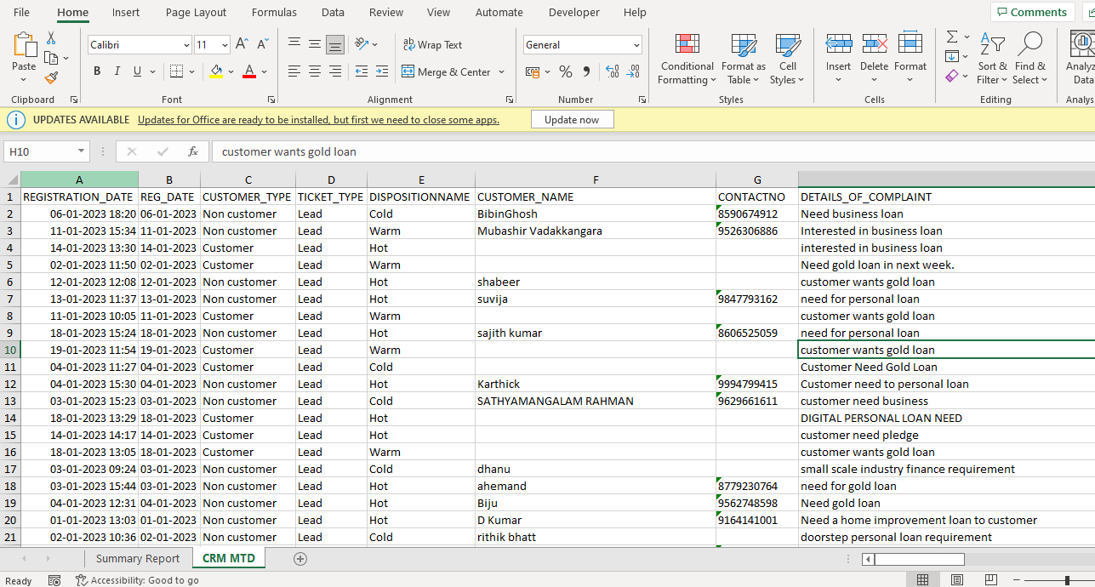

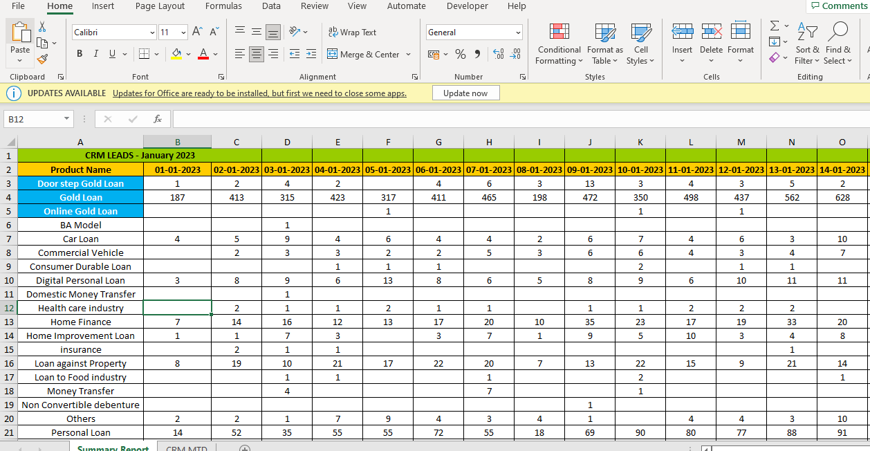

**Mail**

